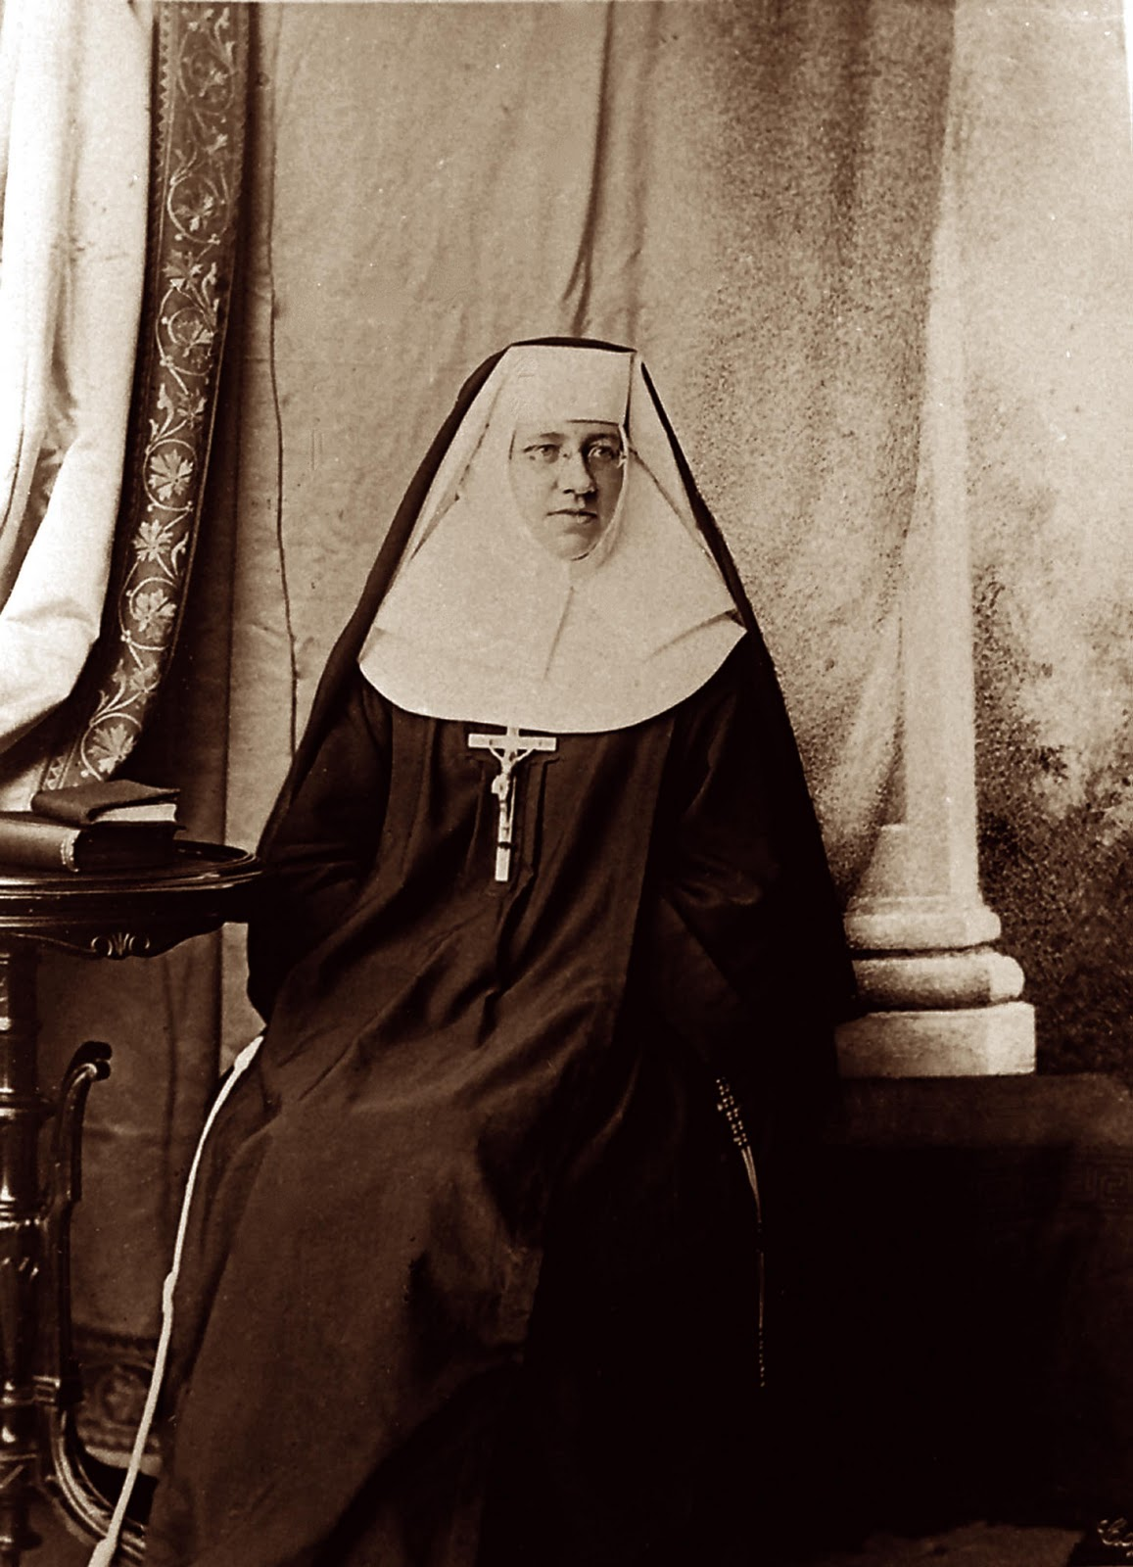

Formation Handbook
St. Katharine Drexel Region
of the
Secular Franciscans

