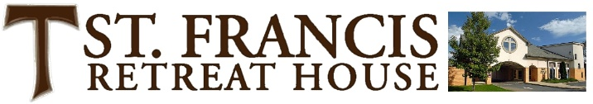

**3908 Chipman Road, Easton, PA 18045 / 610-258-3053, ext. 10**

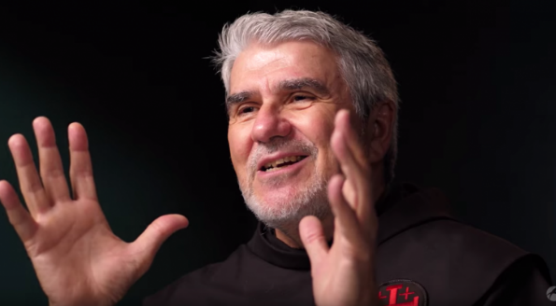

**October 6-8, 2023**

**“Pope Francis’ Encyclical *Fratelli Tutti* through Franciscan Eyes”**

Fr. Greg will explore the content and meaning of Pope Francis’ recent encyclical for its Franciscan elements and its harmony with the Franciscan spiritual tradition and our moral vision.

**Biography**

**Fr. Greg** **Friedman, OFM** is a Franciscan priest of Our Lady of Guadalupe Province, with headquarters in Albuquerque, New Mexico. He serves as Secretary-Treasurer of the province and as Communications Director.

Fr. Greg is best-known for his **video reflections** on the Sunday Gospels at the U.S. Bishops’ website. He has worked as magazine editor, video producer, radio host, and is the author of books and articles on Catholic life. He is also a poet whose work has been published in anthologies and online journals. Fr. Greg has **led pilgrims** in the Holy Land and to places in Rome and Assisi connected to St. Francis and St. Clare of Assisi.

**Registration**

**ST. FRANCIS RETREAT HOUSE ▪ 3918 CHIPMAN ROAD ▪ EASTON, PA 18045 ▪ 610-258-3053**

**WEEKEND RETREAT:** ARRIVAL: 4 PM FRIDAY / DEPARTURE: AFTER LUNCH ON SUNDAY

**ONSITE PRICING INCLUDES:** Private room with bath, all meals, and materials. Please notify us with any accessibility needs or special dietary requirements. **The fee for onsite participation for this retreat is $285,** **for couples $550**, **and the fee for virtual participation is $80**.

**TO REGISTER: 610-258-3053 x 10**, or on our **SFRH WEBSITE:** [www.stfrancisretreathouse.org](http://www.stfrancisretreathouse.org), please register **10 days prior to the retreat for onsite participation** and three days before for virtual participation. Thank you.

***Peace and all goodness to you! The SFRH Friars, Staff, and Volunteers.***

**3918 Chipman Road, Easton, PA 18045 / 610-258-3053, ext. 13**

***SFRH Sponsored 3-Day Retreats***

***Suggested General Outline***

**▪ Friday Evening:**

4-5:30 pm: Arrival at St. Francis Retreat House, Registration, Settling In

**6 pm: Supper**

7 pm: Welcome and Orientation

**7:15 pm: First Presentation**

10 pm: Quiet time and rest

**▪ Saturday:**

**8 am: Breakfast**

**9:15 am: Second Presentation followed by quiet time**

11:15 am: Lectio, Prayer Time, or Eucharist in the Main Chapel

**Noon: Lunch**

1-3:30 pm: Quiet time, Solitude, Rest, Walks, Prayer, Confessions, Spiritual

Direction, Blessed Sacrament in the Portiuncula Chapel

**4 pm: Third Presentation, Discussion, followed by quiet time**

**6 pm: Supper**

**7:15 pm: Fourth Presentation** **and Discussion (sometimes a media presentation)**

8:45 pm: Social time with refreshments

10 pm Quiet time and rest

**▪ Sunday Morning**

**8 am: Light breakfast / Continental breakfast**

**8:45 am: Final Session / Wrap up and “Gathering of the Graces”**

**10 am: Eucharist with the SFRH Sunday Community in Main Chapel**

**11:30 am: Brunch/Lunch together**

1 pm: Departure for home