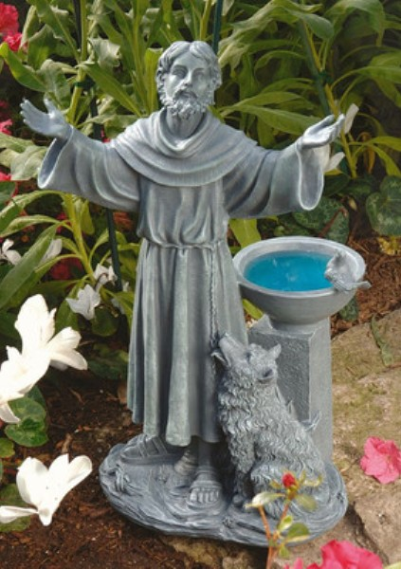
St. Katharine Drexel Region

“Getting St. Francis Out of the Bird Bath!”

Join your brothers and sisters for a weekend relaxing in the Lord,
Presentations to include:

- Letters of St. Francis to Persons he Loved
- Wolf of Gubbio – Francis Teaches Conflict Resolution
- Meaning of the San Damiano Cross
- Update on the State of the Region

Where: St. Francis Retreat Center, 3918 Chipman Road, Easton, PA
When: March 24th – 26th
Check-in: March 24th at 4:00 p.m.
Check-out: March 26^{h} at 11:00 a.m.

Cost: $155 for a single room in the “new” wing; $145 each for a double room in the “new” wing; $145 for a single room w/a shared bath; $135 each for a double room w/a shared bath. Single rooms in either wing will be limited to those with medical need.
WHO’S EXPECTED? YOU and the members of your Fraternity.
RSVP: By February 28, 2017 with your check, payable to St. Katharine Drexel Region, and the form below mailed to Stephanie B. Wiecer, OFS, 5511 Stony Hill Road, New Hope, PA 18938

Name:
Address:
Phone: E-Mail:
Fraternity:_____________________________________________
Amount Enclosed:_____________________
Rooming with:
Dietary Needs:

