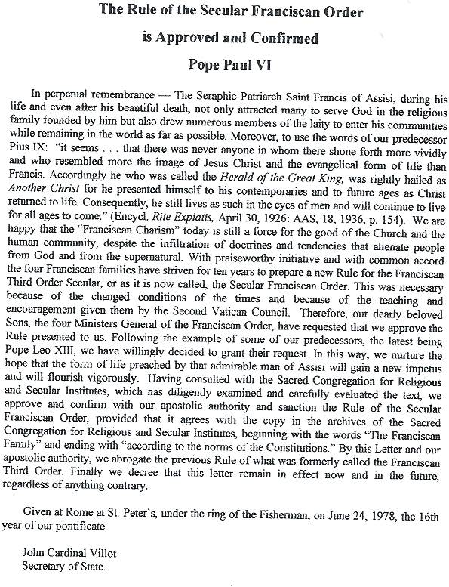

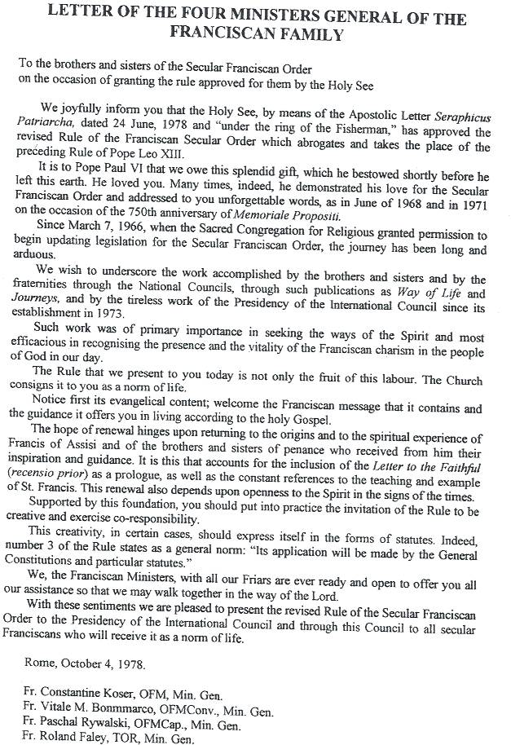

Rule of the Secular Franciscan Order
Prologue
Exhortation of Saint Francis to the Brothers and Sisters in Penance
In the name of the Lord!
Chapter 1
Concerning Those Who Do Penance
All who love the Lord with their whole heart, with their whole soul and mind, with all their strength (cf. Mk 12:30), and love their neighbors as themselves (cf. Mt 22:39) and hate their bodies with their vices and sins, and receive the Body and Blood of our Lord Jesus Christ, and produce worthy fruits of penance.
Oh, how happy and blessed are these men and women when they do these things and persevere in doing them, because "the spirit of the Lord will rest upon them" (cf. Is 11:2) and he will make "his home and dwelling among them" (cf Jn 14:23), and they are the sons of the heavenly Father (cf. Mt 5:45), whose works they do, and they are the spouses, brothers, and mothers of our Lord Jesus Christ (cf. Mt 12:50).
We are spouses, when by the Holy Spirit the faithful soul is united with our Lord Jesus Christ; we are brothers to him when we fulfill "the will of the Father who is in heaven" (Mt 12:50).
We are mothers, when we carry him in our heart and body (cf. 1 Cor 6:20) through divine love and a pure and sincere conscience; we give birth to him through a holy life which must give life to others by example (cf. Mt 5:16).
Oh, how glorious it is to have a great and holy Father in heaven! Oh, how glorious it is to have such a beautiful and admirable Spouse, the Holy Paraclete.
Oh, how glorious it is to have such a Brother and such a Son, loved, beloved, humble, peaceful, sweet, lovable, and desirable above all: Our Lord Jesus Christ, who gave up his life for his sheep (cf. Jn 10:15) and prayed to the Father saying:
"Oh, holy Father, protect them with your name (cf. Jn 17:11) whom you gave me out of the world. I entrusted to them the message you entrusted to me and they received it. They have known that in truth I came from you; they have believed that it was you who sent me. For these I pray, not for the world (cf. Jn 17:9). Bless and consecrate them, and I consecrate myself for their sakes. I do not pray for them alone; I pray also for those who will believe in me through their word (cf. Jn 17:20) that they may be holy by being one, as we are (cf. Jn 17:11). And I desire, Father, to have them in my company where I am to see this glory of mine in your kingdom" (cf. Jn 17:6-24).
Chapter 2
Concerning Those Who Do Not Do Penance
But all those men and women who are not doing penance and do not receive the Body and Blood of our Lord Jesus Christ and live in vices and sin and yield to evil concupiscence and to the wicked desires of the flesh, and do not observe what they have promised to the Lord, and are slaves to the world, in their bodies, by carnal desires and the anxieties and cares of this life (cf. Jn 8:41).
These are blind, because they do not see the true light, our Lord Jesus Christ; they do not have spiritual wisdom because they do not have the Son of God who is the true wisdom of the Father. Concerning them, it is said, "Their skill was swallowed up" (Ps 107:27) and "cursed are those who turn away from your commands" (Ps 119:21). They see and acknowledge; they know and do bad things and knowingly destroy their own souls.
See, you who are blind, deceived by your enemies, the world, the flesh and the devil, for it is pleasant to the body to commit sin and it is bitter to make it serve God because all vices and sins come out and "proceed from the heart of man" as the Lord says in the gospel (cf. Mt 7:21). And you have nothing in this world and in the next, and you thought you would possess the vanities of this world for a long time.
But you have been deceived, for the day and the hour will come to which you give no thought and which you do not know and of which you are ignorant. The body grows infirm, death approaches, and so it dies a bitter death, and no matter where or when or how man dies, in the guilt of sin, without penance or satisfaction, though he can make satisfaction but does not do it.
The devil snatches the soul from his body with such anguish and tribulation that no one can know it except he who endures it, and all the talents and power and "knowledge and wisdom" (2 Chr 1:17) which they thought they had will be taken away from them (cf. Lk 8:18; Mk 4:25), and they leave their goods to relatives and friends who take and divide them and say afterwards, "Cursed be his soul because he could have given us more; he could have acquired more than he did." The worms eat up the body and so they have lost body and soul during this short earthly life and will go into the inferno where they will suffer torture without end.
All those into whose hands this letter shall have come we ask in the charity that is God (cf. 1 Jn 4:17) to accept kindly and with divine love the fragrant words of our Lord Jesus Christ quoted above. And let those who do not know how to read have them read to them.
And may they keep them in their mind and carry them out, in a holy manner to the end, because they are "spirit and life" (Jn 6:64).
And those who will not do this will have to render "an account on the day of judgment" (cf. Mt 12:36) before the tribunal of our Lord Jesus Christ (cf. Rom 14:10).
Chapter One:
The Secular Franciscan Order
- The Franciscan family, as one among many spiritual families raised up by the Holy Spirit in the Church, unites all members of the people of God -- laity, religious, and priests - who recognize that they are called to follow Christ in the footsteps of Saint Francis of Assisi. In various ways and forms but in life-giving union with each other, they intend to make present the charism of their common Seraphic Father in the life and mission of the Church.
- The Secular Franciscan Order holds a special place in this family circle. It is an organic union of all Catholic fraternities scattered throughout the world and open to every group of the faithful. In these fraternities the brothers and sisters, led by the Spirit, strive for perfect charity in their own secular state. By their profession they pledge themselves to live the gospel in the manner of Saint Francis by means of this rule approved by the Church.
- The present rule, succeeding "Memoriale Propositi" (1221) and the rules approved by the Supreme Pontiffs Nicholas IV and Leo XIII, adapts the Secular Franciscan Order to the needs and expectations of the Holy Church in the conditions of changing times. Its interpretation belongs to the Holy See and its application will be made by the General Constitutions and particular statutes.
Chapter Two: The Way Of Life
- The rule and life of the Secular Franciscans is this: to observe the gospel of our Lord Jesus Christ by following the example of St. Francis of Assisi who made Christ the inspiration and the center of his life with God and people.
Christ, the gift of the Father's love, is the way to him, the truth into which the Holy Spirit leads us, and the life which he has come to give abundantly.
Secular Franciscans should devote themselves especially to careful reading of the gospel, going from gospel to life and life to gospel.
- Secular Franciscans, therefore, should seek to encounter the living and active person of Christ in their brothers and sisters, in Sacred Scripture, in the Church, and in liturgical activity. The faith of St. Francis, who often said, "I see nothing bodily of the Most High Son of God in this world except His most holy body and blood," should be the inspiration and pattern of their Eucharistic life.
- They have been made living members of the Church by being buried and raised with Christ in baptism; they have been united more intimately with the Church by profession. Therefore, they should go forth as witnesses and instruments of her mission among all people, proclaiming Christ by their life and words.
Called like Saint Francis to rebuild the Church and inspired by his example, let them devote themselves energetically to living in full communion with the pope, bishops, and priests, fostering an open and 7.trusting dialog of apostolic effectiveness and creativity.
- United by their vocation as "brothers and sisters of penance" and motivated by the dynamic power of the gospel, let them conform their thoughts and deeds to those of Christ by means of that radical interior change which the gospel calls "conversion." Human frailty makes it necessary that this conversion be carried out daily. On this road to renewal the sacrament of reconciliation is the privileged sign of the Father's mercy and the source of grace.
- As Jesus was the true worshipper of the Father, so let prayer and contemplation be the soul of all they are and do. Let them participate in the sacramental life of the Church, above all the Eucharist. Let them join in liturgical prayer in one of the forms proposed by the Church, reliving the mysteries of the life of Christ.
- The Virgin Mary, humble servant of the Lord, was open to His every word and call. She was embraced by Francis with indescribable love and declared the protectress and advocate of his family. The Secular Franciscans should express their ardent love for her by imitating her complete self-giving and by praying earnestly and confidently.
- United themselves to the redemptive obedience of Jesus, who placed His will into the Father's hands, let them faithfully fulfill the duties proper to their various circumstances of life. Let them also follow the poor and crucified Christ, witness to Him even in difficulties and persecutions.
- Trusting the Father, Christ chose for Himself and His mother a poor and humble life, even though He valued created things attentively and lovingly. Let the Secular Franciscans seek a proper spirit of detachment from temporal goods by simplifying their own material needs. Let them be mindful that according to the gospel they are stewards of the goods received for the benefit of God's children.
Thus, in the spirit of the Beatitudes, and as pilgrims and strangers on their way to the home of the Father, they should strive to purify their hearts from every tendency and yearning for possession and power.
- Witnessing to the good yet to come and obligated to acquire purity of heart because of the vocation they have embraced, they should set themselves free to love God and their brothers and sisters.
- As the Father sees in every person the features of his Son, the firstborn of many brothers and sisters, so the Secular Franciscans with a gentle and courteous spirit accept all people as a gift of the Lord and an image of Christ.
A sense of community will make them joyful and ready to place themselves on an equal basis with all people, especially with the lowly for whom they shall strive to create conditions of life worthy of people redeemed by Christ.
- Secular Franciscans, together with all people of good will, are called to build a more fraternal and evangelical world so that the kingdom of God may be brought about more effectively. Mindful that anyone "who follows Christ, the perfect man, becomes more of a man himself," let them exercise their responsibilities competently in the Christian spirit of service.
- Let them individually and collectively be in the forefront in promoting justice by the testimony of their human lives and their courageous initiatives. Especially in the field of public life, they should make definite choices in harmony with their faith.
- Let them esteem work both as a gift and as a sharing in the creation, redemption, and service of the human community.
- In their family they should cultivate the Franciscan spirit of peace, fidelity, and respect for life, striving to make of it a sign of a world already renewed in Christ.
By living the grace of matrimony, husbands and wives in particular should bear witness in the world to the love of Christ for His Church. They should joyfully accompany their children on their human and spiritual journey by providing a simple and open Christian education and being attentive to the vocation of each child.
- Moreover they should respect all creatures, animate and inanimate, which "bear the imprint of the Most High," and they should strive to move from the temptation of exploiting creation to the Franciscan concept of universal kinship.
- Mindful that they are bearers of peace which must be built up unceasingly, they should seek out ways of unity and fraternal harmony through dialogue, trusting in the presence of the divine seed in everyone and in the transforming power of love and pardon. Messengers of perfect joy in every circumstance, they should strive to bring joy and hope to others. Since they are immersed in the resurrection of Christ, which gives true meaning to Sister Death, let them serenely tend toward the ultimate encounter with the Father.
Chapter Three: Life In Fraternity
- The Secular Franciscan Order is divided into fraternities of various levels -- local, regional, national, and international. Each one has its own moral personality in the Church. These various fraternities are coordinated and united according to the norm of this rule and of the constitutions.
- On various levels, each fraternity is animated and guided by a council and minister who are elected by the professed according to the constitutions.
Their service, which lasts for a definite period, is marked by a ready and willing spirit and is a duty of responsibility to each member and to the community.
Within themselves the fraternities are structured in different ways according to the norm of the constitutions, according to the various needs of their members and their regions, and under the guidance of their respective council.
- The local fraternity is to be established canonically. It becomes the basic unit of the whole Order and a visible sign of the Church, the community of love. This should be the privileged place for developing a sense of Church and the Franciscan vocation and for enlivening the apostolic life of its members.
- Requests for admission to the Secular Franciscan Order must be presented to the local fraternity, whose council decides upon the acceptance of new brothers and sisters.
Admission into the Order is gradually attained through a time of initiation, a period of formation of at least one year, and profession of the rule. The entire community is engaged in the process of growth by its own manner of living. The age for profession and the distinctive Franciscan sign are regulated by the statutes. Profession by its nature is a permanent commitment. Members who find themselves in particular difficulties should discuss their problems with the council in fraternal dialogue. Withdrawal or permanent dismissal from the Order, if necessary, is an act of the fraternity council according to the norm of the constitutions.
- To foster communion among members, the council should organize regular and frequent meetings of the community as well as meeting with other Franciscan groups, especially with youth groups. It should adopt appropriate means for growth in Franciscan and ecclesial life and encourage everyone to a life of fraternity. The communion continues with deceased brothers and sisters through prayer for them.
- Regarding expenses necessary for the life of the fraternity and the needs of worship, of the apostolate, and of charity, all the brothers and sisters should offer a contribution according to their means. Local fraternities should contribute toward the expenses of the higher fraternity councils.
- As a concrete sign of communion and co- responsibility, the councils on various levels, in keeping with the constitutions, shall ask for suitable and well prepared religious for spiritual assistance. They should make this request to the superiors of the four religious Franciscan families, to whom the Secular Fraternity has been united for centuries. To promote fidelity to the charism as well as observance of the rule and to receive greater support in the life of the fraternity, the minister or president, with the consent of the council, should take care to ask for a regular pastoral visit by the competent religious superiors as well as for a fraternal visit from those of the higher fraternities, according to the norm of the constitutions.
"May whoever observes all this be filled in heaven with the blessing of the most high Father, and on earth with that of his beloved Son, together with the Holy Spirit, the Comforter."
(Blessing of St. Francis from the Testament)

