***Whatever you ask in my name, I will do it, that the Father may be glorified in the Son; if you ask anything in my name, I will do it. (John 14:13-14)***

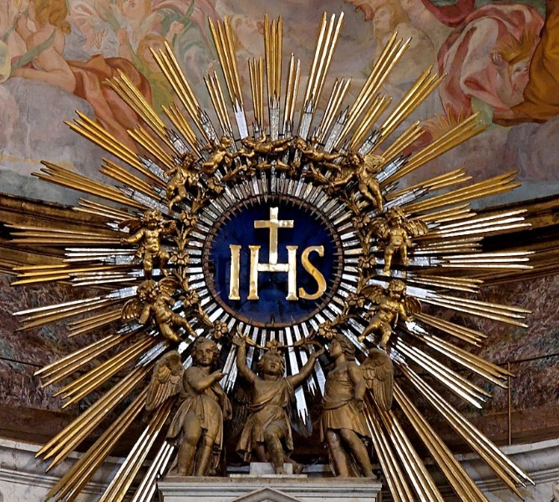St. Francis of Assisi was devoted to the Holy Name of Jesus. His earliest biographer, Thomas of Celano, writes, “the brothers who lived with him know that daily, constantly, talk of Jesus was always on his lips.” Francis was known to speak the name of Jesus as if savoring something delectable. “On his lips,” Celano adds, “the name of Jesus was sweet as honey.”Reverence for the Holy Name became integral to Franciscan spirituality and was spread by the Franciscans.[1]

It reached a special prominence in the early 15th Century when devotion to the Holy Name was promoted by two friars, St. Bernardino of Siena and St. John of Capistrano. St. Bernardino—or Bernardine as he is usually called among English speakers—was one of the most famous preachers in the Italy of his day. Bernardine said that, “the name of Jesus is the glory of preachers, because the shining splendor of that name causes his word to be proclaimed and heard…So this name must be proclaimed, that it may shine out and never be suppressed.”[2] When he preached, Bernardine carried a board with an icon of the Holy Name as a sign of penance and conversion.[3] This icon is the monogram of the Holy Name we are all familiar with: IHS, an abbreviation of IHΣΟΥΣ, which is the name of Jesus in Greek.

Of course, reverence for the Holy Name long predated the Franciscan movement. Jesus told his disciples, “if you ask anything of the Father, he will give it to you in my name.” (John 16:23) The name of Jesus was venerated by the earliest Christians who understood its power. In Acts, we read how Peter healed the lame beggar at the temple’s Beautiful Gate, saying, “I have no silver or gold, but I give you what I have; *in the name* of Jesus Christ of Nazareth, rise and walk.” (Acts 3: 6) As more came to believe in the Resurrection, Peter and John were brought before the Sanhedrin and instructed by the chief priests “not to speak or teach at all *in the name* of Jesus.” (Acts 4:18) They did not heed that warning and were imprisoned and beaten. But upon their release, they left “rejoicing that they were counted worthy to suffer dishonor *for the* *name*. And every day in the temple and at home they did not cease teaching and preaching Jesus as the Christ.” (Acts 5:41-42)

In his letters to the communities he evangelized, St. Paul would later speak of the saving power of the Holy Name: “everyone who calls upon the name of the Lord will be saved.” (Rom. 10:13) He also emphasizes the glory due the name of Jesus. “God has highly exalted him and bestowed on him the name which is above every name, that at the name of Jesus, every knee should bow, in heaven and on earth and under the earth, and every tongue confess that Jesus Christ is Lord, to the glory of God the Father.” (Phil. 2:9-11).

As Secular Franciscans “going from gospel to life and life to the gospel,”[4] we do well to take these scriptures to heart and live and act in their spirit. Without question in our day and age, the Holy Name retains its power and glory for us. We do well to pray to the Father in the name of Jesus, although we should never invoke the Holy Name thoughtlessly or from mere habit. We should speak it from our hearts, savoring it for its beauty and sweetness after the example of our Seraphic Father St. Francis.

There are other steps we can take as well. It goes without saying that we should never speak the Lord’s name in vain or in anger or as an idle exclamation. But are we prepared to challenge others who do? Many of us were taught to bow our heads when we spoke or heard the name of Jesus. Can we continue that simple reverence, even though it may require a bit of courage in contemporary settings?

We should also look for ways to speak of Jesus among our families and fraternities. Doing so is always a sign of the strength of a Christian community. With joy and humility, we praise him in the Gloria as the “Lamb of God,” the “Holy One,” the “Lord,” the “Most High.” But when we speak his beautiful name, Jesus, we also remind ourselves that he walked the earth a person like us who “shared our human nature in all things but sin.”[5] Pope Benedict XVI, has written, “Being Christian is not the result of an ethical choice or a lofty idea, but the encounter with an event, a person.”[6] That person is the one whom we love and who loves us, and his name is Jesus.

**\*\*\*\*\*\*\*\*\*\*\*\*\*\*\*\*\*\*\*\*\*\*\*\*\*\*\*\*\*\*\*\*\*\*\*\*\*\*\*\*\*\*\*\*\*\*\*\*\*\***

**From the OFS Rule and General Constitutions**

* They have been made living members of the Church by being buried and raised with Christ in baptism; they have been united more intimately with the Church by profession. Therefore, they should go forth as witnesses and instruments of her mission among all people, proclaiming Christ by their life and words. [*Rule*, 6]
* Mindful that the Holy Spirit is the source of their vocation and the animator of fraternal life and mission, Secular Franciscans should seek to imitate the faithfulness of Francis to His inspiration. They should listen to the exhortation of the Saint to desire above all things ‘the Spirit of the Lord and Its holy activity.” [*Constitutions*, 11]

**For reflection and meditation**

* This Lent, take time to meditate on the Holy Name of Jesus. One way to do this is to include the Litany of the Holy Name of Jesus in your prayers. It can be found here: www.usccb.org/prayer-and-worship/prayers-and-devotions/litanies/litany-of-the-holy-name-of-jesus.

1. “Reflections on the Name of Jesus,” <https://www.franciscantradition.org/blog/2-reflections-on-the-holy-name-of-jesus>, accessed 1-11-2021.
2. “IHS: The Holy Name of Jesus: St Bernardino of Siena,” <http://idlespeculations-terryprest.blogspot.com> /2011/01/ihs-holy-name-of-jesus.html, accessed 1-11-2021.
3. “Reflections on the Name of Jesus.”
4. Rule of the Secular Franciscan Order, Article 4.
5. Fourth Eucharistic Prayer, [Eucharistic Prayers I-IV (catholic-resources.org)](https://www.catholic-resources.org/ChurchDocs/RM3-EP1-4.htm).
6. “Deus Caritas Est,” 1, [www.vatican.va/content/benedict-xvi/en/encyclicals/documents/hf_ben-xvi_enc_20051225_deus-caritas-est.html](http://www.vatican.va/content/benedict-xvi/en/encyclicals/documents/hf_ben-xvi_enc_20051225_deus-caritas-est.html), accessed 2-15-2021.

   **Image:** IHS monogram, on top of the main altar of the Church of the Gesù, Rome, Italy. (Wikimedia Commons, public domain).