“Spiritual Asst. Appointments August 2018 – OFS-USA Website SA Documents

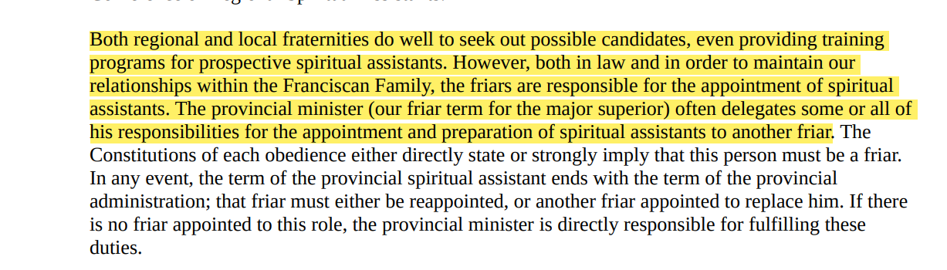

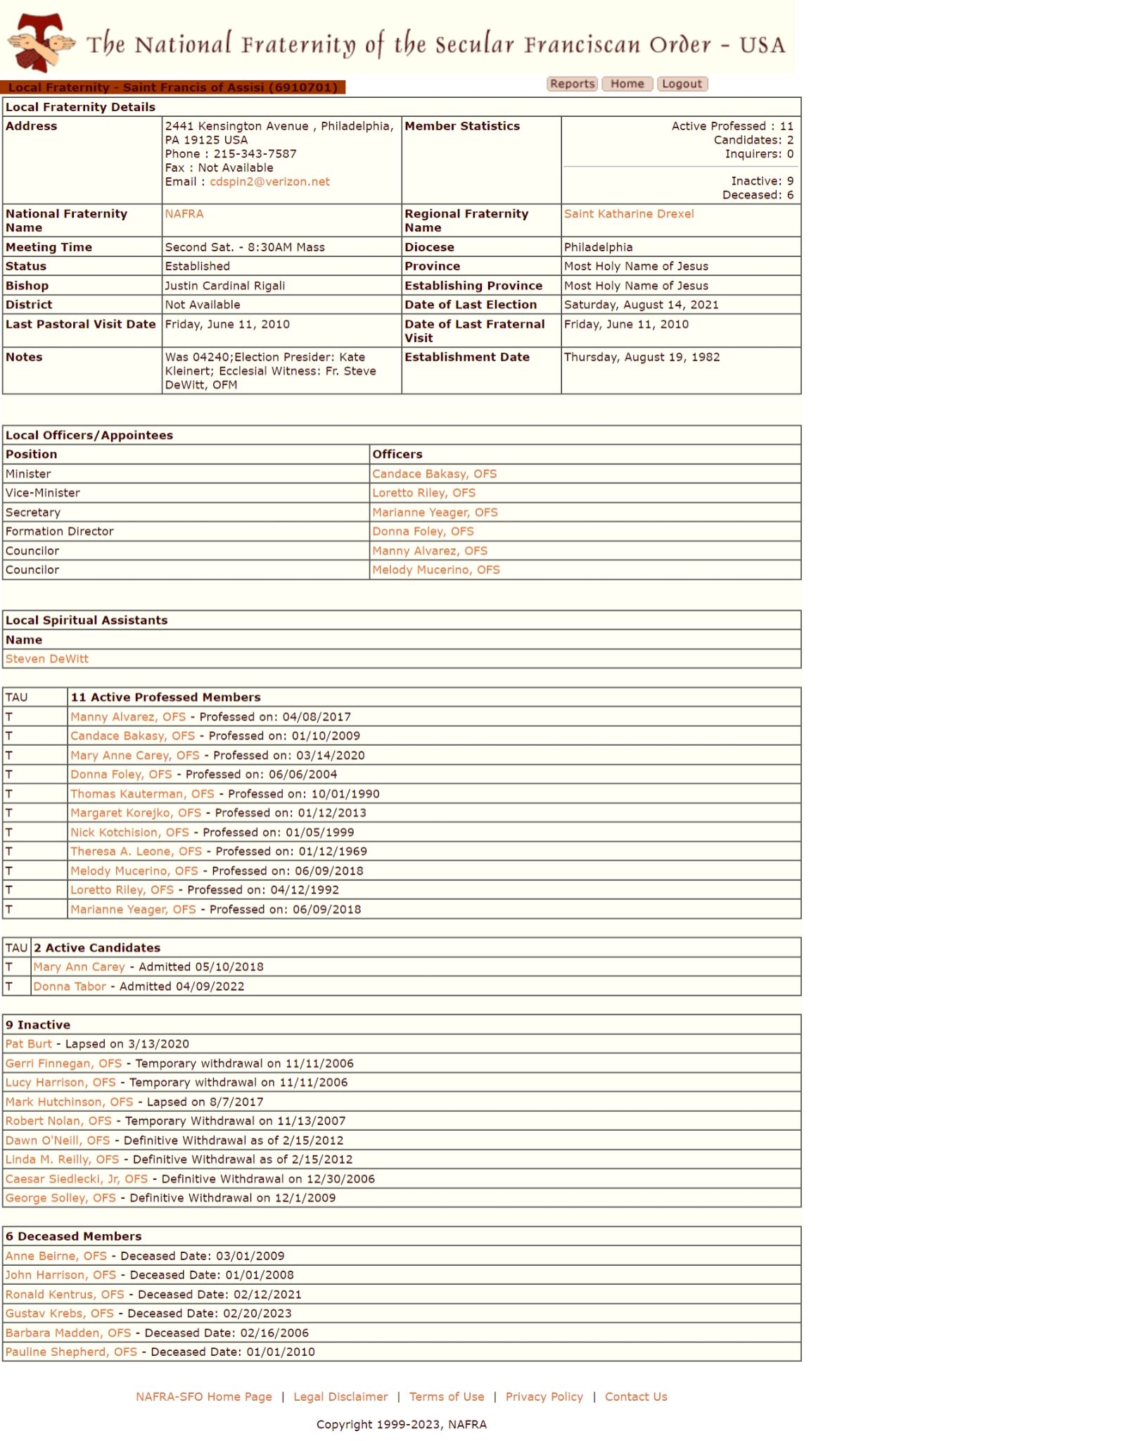

St. Francis, Phila.

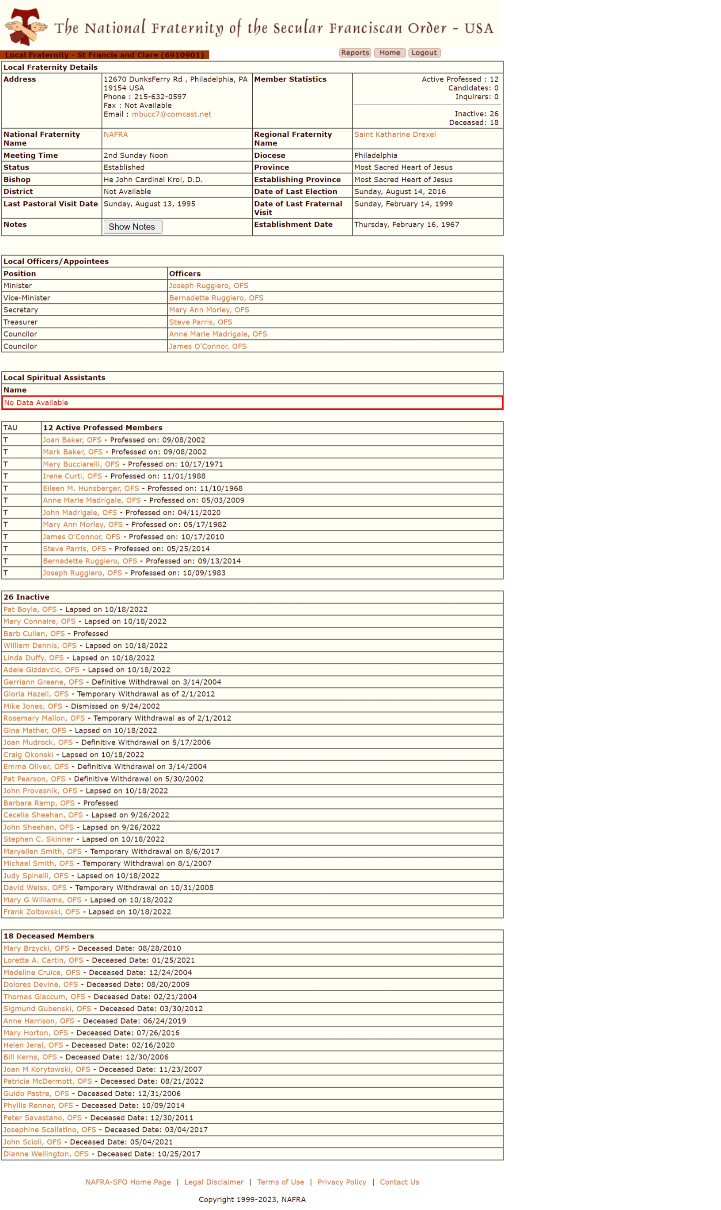

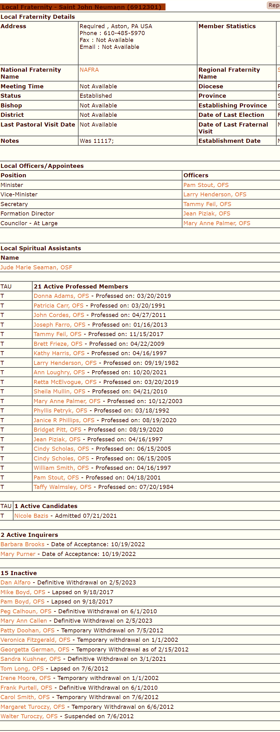

St. John Neumann, Aston

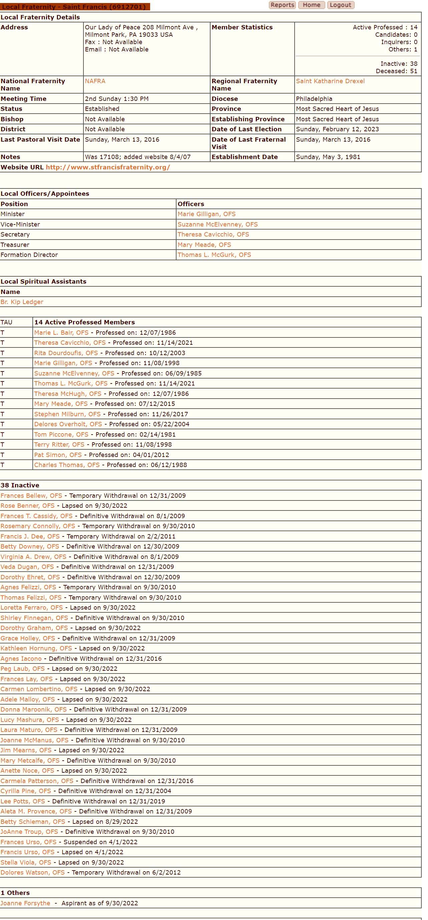

St. Francis, Milmont Park

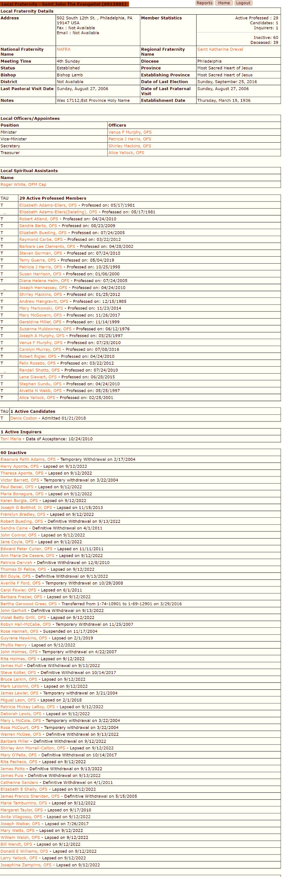St.

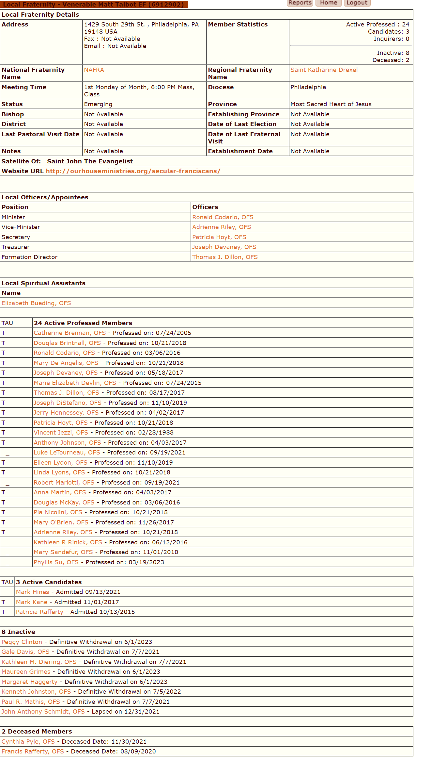

Ven. Matt Talbot, Phila.

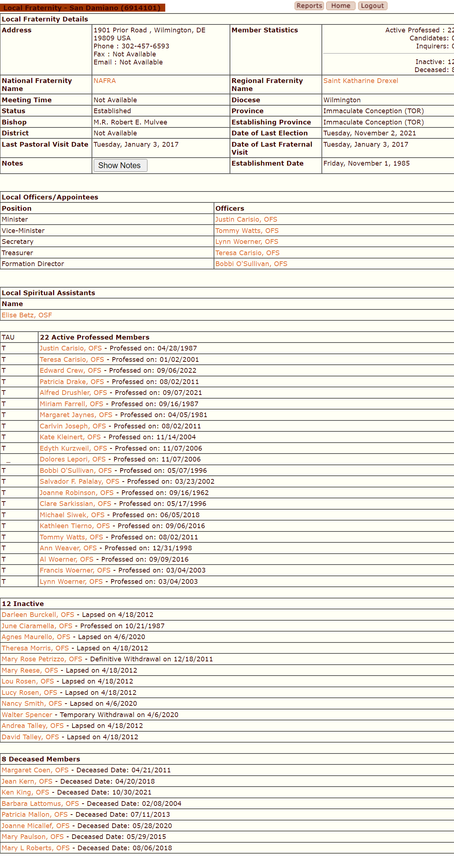San Damiano,

Wilmington, DE