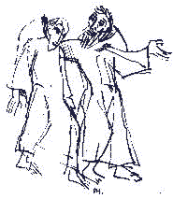Let us serve like Jesus - Let us Journey together

**Definitive Withdrawal**

1. Definitive Withdrawal (GC 58.1) is a permanent separation of a professed member from the Order. The member who intends to withdraw definitively from the Order communicates this in writing to the Minister.
   1. The Minister and Spiritual Assistant of the fraternity, with charity and prudence, discuss the matter with the person concerned and keep the Council informed.
   2. If the member confirms the decision in writing, Council takes notice of it and communicates the decision in writing to the person concerned and records it in the proceedings of the fraternity.
   3. The Definitive Withdrawal is recorded in the register of the fraternity.
2. Council is to maintain records of the initial request, all communications with the member, the Council’s decision, and the member’s confirmation of the decision. These documents are also transmitted to the Regional Minister, who retains a copy and forwards them to the National Council (GC 58.1).
   1. The declaration that the person has ceased to be a member of the Order, in order to become effective, must be confirmed by the National Executive Council to whom all the documentation will be sent (GC 58.4).
   2. If confirmed, the National Database is then updated to reflect the person as Definitively Withdrawn. This is not reversible.