Stations Of The Cross

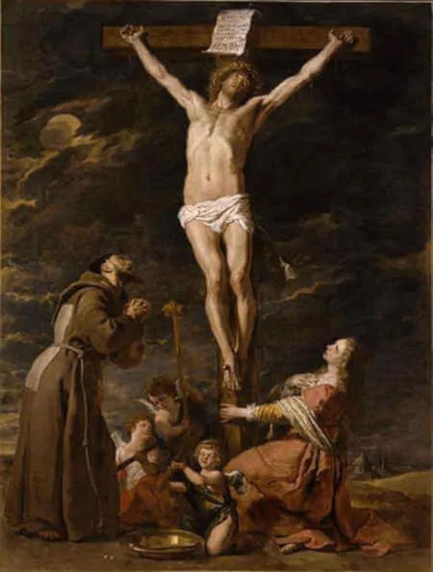

By

St. Francis of Assisi

*\*Kneeling before the altar, make an Act of Contrition, and form the intention of gaining the indulgences, whether for yourself or for the souls in Purgatory.\**

*(The people’s responses are in bold.)*

Preparatory Prayer:

**Most merciful Lord, with a contrite heart and penitent spirit I bow down before Thy divine Majesty. I adore Thee as my supreme Lord and Master. I believe in Thee, I hope in Thee, I love Thee above all things. I am heartily sorry for having offended Thee, my only and supreme God. I firmly resolve to amend my life; and although I am unworthy to obtain mercy, yet looking upon Thy holy Cross I am filled with peace and consolation. I will, therefore, meditate on Thy sufferings, and visit the Stations in company with Thy sorrowful Mother and my holy Guardian Angel, to promote Thy honor and to save my soul.**

**I desire to gain all indulgences granted to this holy exercise for myself and for the souls in Purgatory.**

**O Loving Jesus, inflame my cold heart with Thy love, that I may perform this devotion as perfectly as possible, and that I may live and die in union with Thee. Amen.**

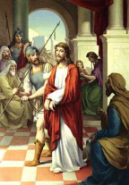

First Station - Jesus Is Condemned to Death

V. We adore You, O Christ, and we praise You.

R. **Because by Your holy Cross, You have redeemed the world.**

Jesus, the most innocent of beings, is condemned to death, yes, to the shameful death of the cross. In order to remain a friend of Caesar, Pilate delivers Jesus into the hands of His enemies. O fearful crime, to condemn Innocence to death and to displease God in order to please men.

**O innocent Jesus, * I have sinned and I am guilty of eternal death; * but that I may Live, * Thou dost gladly accept the unjust sentence of death. * For whom then shall I henceforth live * if not for Thee, my Lord? * If I desire to please men, * I can not be Thy servant. * Let me, therefore, rather displease the whole world * than not please Thee, O Jesus!**

[Our Father, Hail Mary, Glory be.]

V. Lord Jesus, crucified.

R. **Have mercy on us.**

*Through her heart, His sorrow sharing,*

*All His bitter anguish bearing,*

*Now at length the sword had passed.*

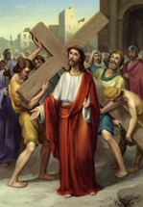

Second Station - Jesus Carries His Cross

V. We adore You, O Christ, and we praise You.

R. **Because by Your holy Cross, You have redeemed the world.**

When our divine Redeemer beheld the Cross, He most willingly reached out to it with His bleeding arms. He embraced it lovingly, kissed it tenderly, took it on His bruised shoulders, and, exhausted as He was, He carried it joyfully.

**O my Jesus, * I can not be Thy friend and follower * if I refuse to carry my cross. * O beloved cross, * I embrace Thee, * I kiss Thee, * I joyfully accept Thee from the hand of my God. * Far be it from me to glory in anything * save in the Cross of my Lord and Redeemer. * By it the world shall be crucified to me, * and I to the world, * that I may be Thine forever.**

[Our Father, Hail Mary, Glory be.]

V. Lord Jesus, crucified.

R. **Have mercy on us.**

*O, how sad and sore distressed*

*Was that Mother, highly blest,*

*Of the sole begotten One!*

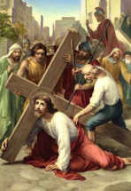

Third Station - Jesus Falls the First Time

V. We adore You, O Christ, and we praise You.

R. **Because by Your holy Cross, You have redeemed the world.**

Carrying the Cross, our dear Savior was so weakened with its heavy weight that He fell exhausted to the ground. The Cross was light and sweet to Him, but our sins made it so heavy and hard to carry.

**Beloved Jesus, * Thou didst carry the burden and the heavy weight of my sins. * Should I then not bear in union with Thee * my light burden of suffering, * and accept the sweet yoke of Thy commandments? * Thy yoke is sweet and Thy burden is light. * I willingly accept it. * I will take up my cross and follow Thee.**

[Our Father, Hail Mary, Glory be.]

V. Lord Jesus, crucified.

R. **Have mercy on us.**

*Christ above in torment hands:*

*She beneath beholds the pangs*

*Of her dying glorious Son.*

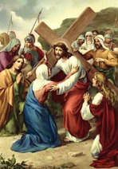

Fourth Station - Jesus Meets His Blessed Mother

V. We adore You, O Christ, and we praise You.

R. **Because by Your holy Cross, You have redeemed the world.**

How sad and how painful must it have been for Mary to behold her beloved Son laden with the Cross, covered with wounds and blood, and driven through the streets by savage executioners! What unspeakable pangs her most tender heart must have experienced! How earnestly did she desire to die instead of Jesus, or at least with Him!

**O Jesus, * O Mary, * I am the cause of the pains that pierced your hearts. * Would that my heart might experience some of your sufferings. * O Mother, * let me share in thy sufferings and those of thy Son, * that I may obtain the grace of a happy death.**

[Our Father, Hail Mary, Glory be.]

V. Lord Jesus, crucified.

R. **Have mercy on us.**

*Is there one who would not weep,*

*Whelmed in miseries so deep,*

*Christ’s dear Mother to behold?*

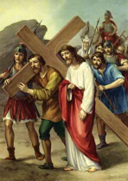

Fifth Station - Simon of Cyrene Helps Jesus Carry His Cross

V. We adore You, O Christ, and we praise You.

R. **Because by Your holy Cross, You have redeemed the world.**

Simon of Cyrene was forced to help our exhausted Savior carry His Cross. How pleased would Jesus have been, had Simon offered his services of his own accord. However, Simon was not invited by Christ as you are. He says: "Take up your cross and follow Me." Nevertheless you recoil, and carry it grudgingly.

**O Jesus, * whosoever does not take up his cross and follow Thee, * is not worthy of Thee. * Behold, I cheerfully join Thee on the way of the cross. * I desire to carry it with all patience until death, * that I may prove worthy of Thee.**

[Our Father, Hail Mary, Glory be.]

V. Lord Jesus, crucified.

R. **Have mercy on us.**

*Can the human heart refrain*

*From partaking in her pain,*

*In that Mother’s pain untold?*

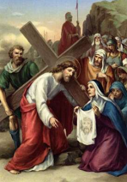

Sixth Station - Veronica Wipes the Face of Jesus

V. We adore You, O Christ, and we praise You.

R. **Because by Your holy Cross, You have redeemed the world.**

Moved by compassion, Veronica presents her veil to Jesus, to wipe His disfigured face. He imprints on it His holy countenance, and returns it to her as a recompense. Shall Christ reward you in like manner? Then you too must do Him a service. But you do a service to Christ every time you perform a work of mercy towards your neighbor: for He says: "What you have done to the least of My brethren, you have done to Me."

**Dearest Jesus, * what return shall I make Thee for all Thy benefits? * Behold, I consecrate myself entirely to Thy service. * My whole heart I give to Thee; * stamp on it Thy holy image, * that I may never forget Thee.**

[Our Father, Hail Mary, Glory be.]

V. Lord Jesus, crucified.

R. **Have mercy on us.**

*Bruised, derided, cursed, defiled,*

*She beheld her tender Child,*

*All with bloody scourges rent.*



Seventh Station - Jesus Falls the Second Time

V. We adore You, O Christ, and we praise You.

R. **Because by Your holy Cross, You have redeemed the world.**

Overwhelmed by the weight of the Cross, Jesus falls again to the ground. But the cruel executioners do not permit Him to rest a moment. With thrusts and blows they urge Him onward. With what cruelty Jesus in treated and trampled under foot! Remember, compassionate soul, that your sins caused Jesus this painful fall.

**Have mercy on me, O Jesus, * and help me never to fall into my former sins. * From this moment I will strive sincerely * never to sin again. * But Thou, O Jesus, strengthen me with Thy grace, * that I may faithfully carry out my resolution.**

[Our Father, Hail Mary, Glory be.]

V. Lord Jesus, crucified.

R. **Have mercy on us**.

*For the sins of His own nation,*

*Saw Him hang in desolation*

*Till His spirit forth He sent.*

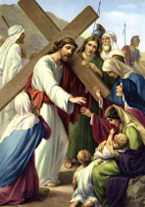

Eighth Station - Jesus Speaks to the Women of Jerusalem

V. We adore You, O Christ, and we praise You.

R. **Because by Your holy Cross, You have redeemed the world.**

Moved by compassion, these devoted women weep over our suffering Savior. But He turns to them and says: "Weep not for Me, but weep for yourselves and your children. Weep for your sins and those of your children; for they are the cause of My suffering." You also must weep over your sins, for there is nothing more pleasing to our Lord and more useful to yourself than the tears you shed out of contrition for your sins.

**O Jesus, * who shall give my eyes a torrent of tears, * that I may day and night weep over my sins? * I beseech Thee by Thy bitter and bloody tears * to move my heart, * so that tears may flow in abundance from my eyes, * and that I may weep over Thy sufferings * and over my sins until death.**

[Our Father, Hail Mary, Glory be.]

V. Lord Jesus, crucified.

R. **Have mercy on us.**

*O thou Mother: font of love!*

*Touch my spirit from above,*

*Make my heart with thine accord.*

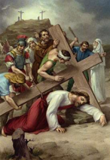

Ninth Station - Jesus Falls the Third Time

V. We adore You, O Christ, and we praise You.

R. **Because by Your holy Cross, You have redeemed the world.**

Exhausted at the foot of Calvary, Jesus falls for the third time to the ground. How painfully must have been reopened all the wounds of His tender body by these repeated falls. And how enormous must my sins be, to cause Jesus to fall so painfully. Had not Jesus taken my sins upon Himself, they would have plunged me into the abyss of Hell.

**Most merciful Jesus, * I return Thee a thousand thanks * for not permitting me to die in my sins * and fall into the abyss of Hell, * as I have deserved so often. * Enkindle in me a sincere desire to amend my life. * Let me never again fall into sin, * but grant me the grace of final perseverance.**

[Our Father, Hail Mary, Glory be.]

V. Lord Jesus, crucified.

R. **Have mercy on us.**

*Make me feel as thou has felt;*

*Make my soul to glow and melt,*

*With the love of Christ my Lord.*

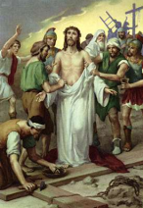

Tenth Station - Jesus Is Stripped of His Garments

V. We adore You, O Christ, and we praise You.

R. **Because by Your holy Cross, You have redeemed the world.**

Arriving on Calvary, Jesus was cruelly deprived of His garments. How painful the stripping must have been, because the garments adhered to His mangled body, so that in removing them parts of the flesh were torn away. Jesus is deprived of His garments that He may die possessed of nothing. How happy shall not I die after laying aside my evil habits and tendencies!

**Help me, O Jesus, to amend my life. * Let it be renewed according to Thy will and desire. * However painful the correction may be to me, * I will not spare myself. * With the assistance of Thy grace, * I will refrain from all sinful pleasure and vain amusement, * that I may die happy and live forever.**

[Our Father, Hail Mary, Glory be.]

V. Lord Jesus, crucified.

R. **Have mercy on us**.

*Holy Mother, pierce me through;*

*In my heart each wound renew*

*Of my Savior crucified.*

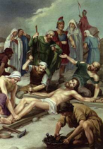

Eleventh Station - Jesus Is Nailed to the Cross

V. We adore You, O Christ, and we praise You.

R. **Because by Your holy Cross, You have redeemed the world.**

Stripped of His garments, Jesus is violently thrown down on the Cross. His hands and His feet are nailed to it in the most cruel way. Jesus remains silent, because it so pleases His heavenly Father. He suffers patiently, because He suffers for you. How do you act in sufferings and trials? How fretful and impatient, how full of complaints are you!

**O Jesus, * meek and patient Lamb, * I renounce forever my impatience. * Crucify, O Lord, my flesh, * with its evil desires and vices. * Punish and afflict me in this life, * but spare me in the next. * I resign myself altogether to Thy holy will. * May it be done in all things.**

[Our Father, Hail Mary, Glory be.]

V. Lord Jesus, crucified.

R. **Have mercy on us.**

*Let me share with Thee His pain,*

*Who for all my sins was slain,*

*Who for me in torment died.*

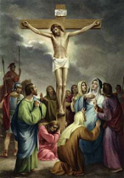

Twelfth Station - Jesus Dies on the Cross

V. We adore You, O Christ, and we praise You.

R. **Because by Your holy Cross, You have redeemed the world.**

Behold Jesus crucified! Behold His wounds received for love of you! His whole appearance betokens love. His head is bent to kiss you. His arms are extended to embrace you. His heart is open to receive you. Oh what love! Jesus dies on the Cross, to preserve you from eternal death.

**Most lovable Jesus, * who will grant that I may die for love of Thee? * I will endeavor to die to the world and its vanities * when I behold Thee on the Cross * covered with wounds and crowned with thorns. * Merciful Jesus, * take me into Thy wounded heart, * that I may despise all perishable things, * to live and die for Thee alone.**

[Our Father, Hail Mary, Glory be.]

V. Lord Jesus, crucified.

R. **Have mercy on us.**

*Let me mingle tears with thee,*

*Mourning Him who mourned for me,*

*All the days that I may live.*

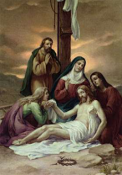

Thirteenth Station - Jesus Is Taken Down From the Cross

V. We adore You, O Christ, and we praise You.

R. **Because by Your holy Cross, You have redeemed the world.**

Jesus did not descend from the Cross, but remained on it till His death. When taken down, He rested on the bosom of His beloved Mother as He had so often done in life. Persevere in your good resolutions, and do not flee from the cross. For he who perseveres till the end shall be saved. Consider, moreover, how pure the heart should be that receives the body and blood of Jesus Christ in the adorable Sacrament of the Altar.

**O Lord Jesus crucified! * I most earnestly entreat Thee: * Help me do what is right * and let me not be separated from Thy Cross, * for on it I desire to live and to die. * Create in me, O Lord, a clean heart, * that I may worthily receive Thee in Holy Communion, and that Thou mayest remain in me, * and I in Thee, * for all eternity.**

[Our Father, Hail Mary, Glory be.]

V. Lord Jesus, crucified.

R. **Have mercy on us.**

*By the cross with thee to stay;*

*There with thee to weep and pray*

*Is all I ask of thee to give.*

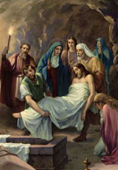

Fourteenth Station - Jesus Is Laid in the Tomb

V. We adore You, O Christ, and we praise You.

R. **Because by Your holy Cross, You have redeemed the world.**

The body of Jesus is laid in a stranger’s tomb. He Who in this world had not whereon to rest His head, would have no grave of His own after death. You whose heart is still attached to this world, despise it that you may not perish with it.

**O Jesus, * Thou hast singled me out from the world, * what then shall I seek in it? * Thou hast created me for Heaven, * what then shall I desire upon earth? * Depart from me, deceitful world, with thy vanities! Henceforth I will walk the way of the Cross * traced out for me by my Redeemer, * and journey onward to my heavenly home, * where my rest and my joy shall be forever.**

[Our Father, Hail Mary, Glory be.]

V. Lord Jesus, crucified.

R. **Have mercy on us.**

*Virgin of all virgins best,*

*Listen to my fond request:*

*Let me share thy grief divine.*

**Concluding Prayer:**

Almighty and eternal God, merciful Father, who hast given to the human race Thy beloved Son as an example of humility, obedience, and patience, to precede us on the way of life, bearing the cross:

Graciously grant us that we, inflamed by His infinite love, may take up the sweet yoke of His Gospel together with the mortification of the cross, following Him as His true disciples, so that we shall one day gloriously rise with Him and joyfully hear the final sentence:

“Come, ye blessed of My Father, and possess the kingdom which was prepared for you from the beginning,” where Thou reignest with the Son and the Holy Ghost, and where we hope to reign with Thee, world without end. Amen.--*Saint Francis of Assisi*