Visual Meditation

Gaze on Him
visually embrace the crucified Christ

“Who are you O God, and who am I?”

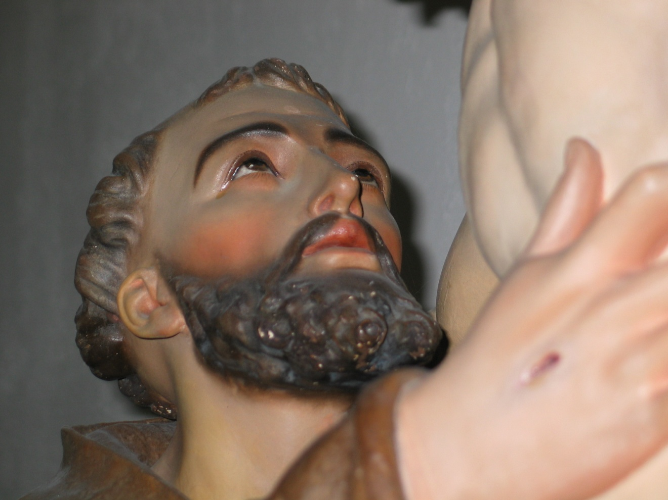

Consider Him
how do I participate in His life
loving, forgiving & healing, hold and return His loving gaze

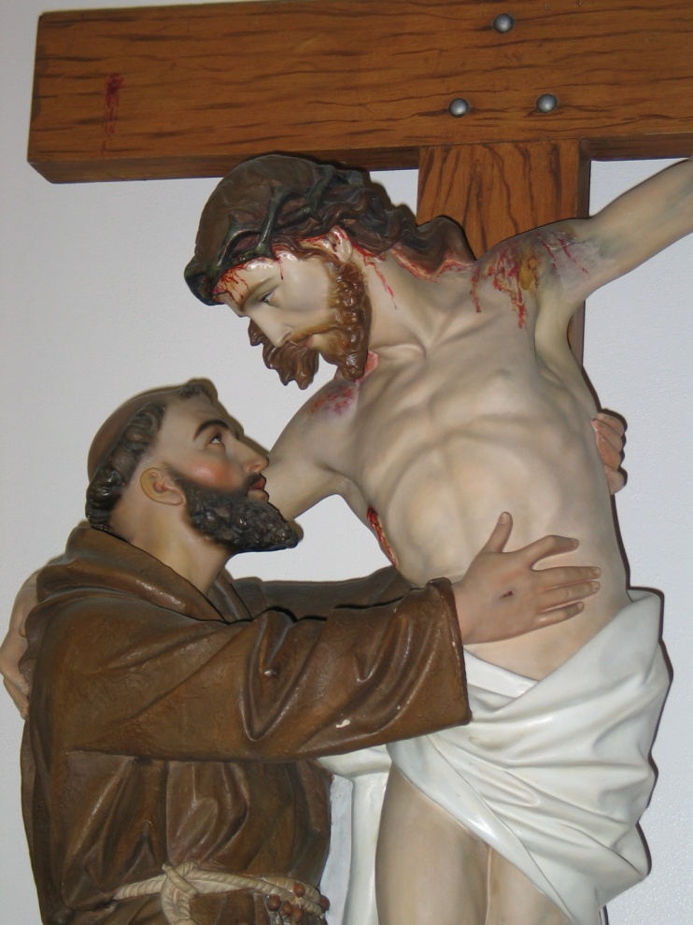

Contemplate Him
Spend some time and take a long loving look at the divine
move beyond ourselves and allow ourselves to be transformed to imitate.
What does Jesus, gaze express?


Imitate Him
become that which we love in reality & action.
Leads us to see God in all creation & invites our participation







